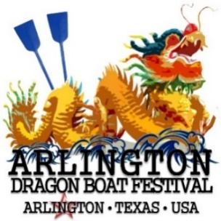

Viridian Lake Club
1200 Viridian Park Ln, Arlington Texas

Organization: |  | Contact:
Title: |  | E-mail:
Address:
Phone: |  | Fax:

Sponsorship Levels:
Inaugural Presenting Partner ($8,000)
Includes two team of twenty-one members, one premier booth, organization’s name on all social media, press release and program book; speaking opportunity at Opening and Closing Ceremonies; organization’s logo on website; sponsor flag on the race field (if applicable), T-shirts for Captains of the teams, training for rowers, award presentation on stage
Inaugural Partner ($6,000)
Includes one team of twenty-one members, one premier booth, organization’s name on all social media, press release and program book; speaking opportunity at Opening Ceremony; organization’s logo on website; sponsor flag on the race field (if applicable)
Supporting Partner ($2,000)
Includes one team of twenty-one members; one booth, give welcome at the Opening Ceremony; organization’s logo on website and program book

*********************************************************************************************************
Payment Information:
Form of Payment (please specify): Check Credit Card [MC VISA AMEX DISCOVER]
Credit Card #: |  | 3 Digit Security Code:
Cardholder’s Name: |  | Exp. Date:
Billing Address: |  | Signature:
By check: Please make checks payable to USPAACC-SW Education Foundation and mail to 711 E. Lamar Blvd., Ste. 211 (mailbox 103a), Arlington, TX 76011.
All payments are final, non-refundable, and non-transferable.

