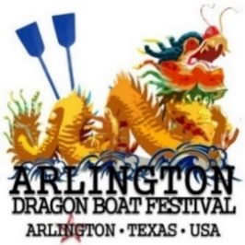
Dragon Boat Festival – Race for Education
Arlington and Tarrant County Region

Presented by US Pan Asian American Chamber – SW
Education Foundation

Saturday, June 15, 2019 8:30 AM – 4:00 PM

Registration Form

Viridian Lake Club
1200 Viridian Park Ln, Arlington Texas

All payments must accompany this completed Team Application Form. Registration is on a First-come, First-serve basis. There is a maximum of 18 team spots. Once they are filled, subsequent teams will be placed on a waiting list. Forms submitted without payment will be considered incomplete. Please mail or fax completed form and payments to US Pan Asian American Chamber –Southwest Education Foundation, 711 E. Lamar Blvd., Mailbox 103A, Suite 211, Arlington, Texas 76011. Fax: 817-469-9485.

APPLICATION DEADLINES: *Registration is on a First-come First-serve basis*

- Early Bird Registration Fee: Must be received by April 30, 2019
Twelve Hundred Dollars ($1,200.00) Per Team (21 people).

- General Registration Fee: Must be received by May 18, 2019
Fourteen Hundred Dollars ($1,400.00) Per Team (21 people).

Team Information:

Organization/Company: |  | Team Name:
Team Captain’s Name:  Email Address:  Phone: |  | Sponsor Name:  Email Address:  Phone:

Payment Information:

Form of Payment (please specify): Check Credit Card [MC VISA AMEX DISCOVER]
Credit Card #: |  | 3 Digit Security Code:
Cardholder’s Name: |  | Exp. Date:
Billing Address: |  | Signature:
By check: Please make checks payable to USPAACC-SW Education Foundation and mail to 711 E. Lamar Blvd., Suite 211 Arlington, Texas 76011.
All payments are final, non-refundable, and non-transferable.

Please fax completed registration form to 817-469-9485 or email: an@uspaacc-sw.org
Address: 711 E. Lamar Blvd., Ste. 211 (mailbox 103a), Arlington, TX 76011 Bus: 817-874-3195

